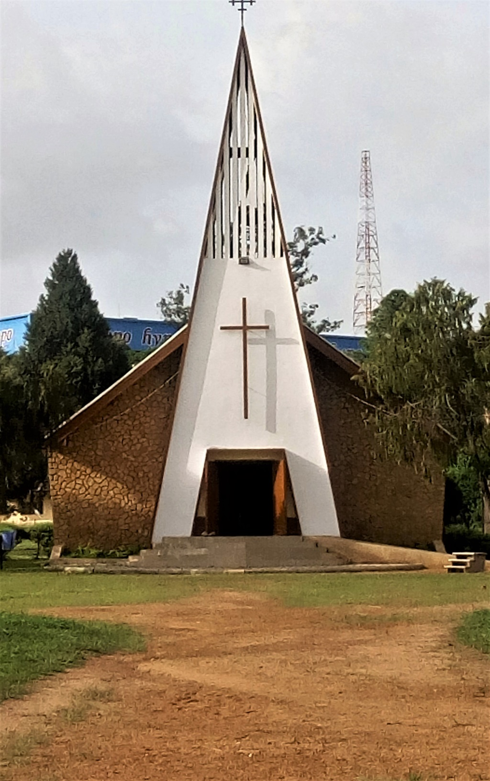

**Theological College of Northern Nigeria (TCNN)**

Box 64, 930008 Bukuru, Plateau State, Nigeria

info@tcnn.edu.ng **|** tcnn.edu.ng

**An affiliate of Association for Christian Theological**

**Education in Africa (ACTEA) *acteaweb.org***

**APPLICATION FORM**

**FORM NO.**

|  |  |  |  |  |  |
| --- | --- | --- | --- | --- | --- |
|  |  |  |  |  |  |



**Choose Course applied for**

*(Tick (🗹) the appropriate box.)*

***Bachelor of Divinity (BD) – 4 yrs.***

***Bachelor of Divinity – Public Theology – 4 yrs.***

***Bachelor of Art – Ling. & Bible Trans. - 4 yrs.***

***Diploma in Theology (Dip. Th) – 2 yrs***

***Diploma in Church Music (Dip. CM) - 2 yrs***

***Diploma in Theo. & Gender Studies – 2 yrs***

*\* Areas of specialization varies yearly. You can check our website for more information.*

*\*\* Those applying for ANY of the graduate programmes are required to submit this form with their project proposals.*

**Programme type**

***Full time Part time Online training***

***Doctor of Ministry (D. Min.) – 4 yrs.\*\****

***Doctor of Philosophy (Ph.D) – 4 yrs.\*\****

***Master of Arts – Ling. & Bible Translation***

***(MA-LBT) - 2 yrs.***

***Master of Theology (MTh)* - 2 yrs.***

***Master of Public Theology (MPTh) – 2 yrs.***

***Postgraduate Diploma in Theo. (PGD-Th.) – 1 yr.***

***Postgraduate Diploma in Public Theology***

***(PGD-PTh) – 1 yr***

***Postgraduate Diploma in Linguistics and***

***Bible Translation (PGD-LBT) – 1 yr.***

***Master of Divinity (MDiv.) – 2 yrs.***

***Master of Divinity in Public Theology – 2 yrs.***

Instructions

**PHOTO**

**HERE**

*a. Fill in the appropriate space(s) provided with the required details.*

*b. Please ensure the information you will provide here are* ***true*** *and* ***correct****.*

*c. Boxes are provided for characters to be entered; each character should be in a box. Leave an* ***empty box*** *between every* ***word****.*

*d. Where appropriate, tick 🗹 the correct box option.*

*e. Attach relevant documents with this form on submission.*

*f. Be assured that information provided here will be treated confidentially.*

`

Baptismal Info & Others

When were you baptized?

Where were you baptized?

Who baptized you?

Personal Information

**First name**:

**Last name:**

**Address 1:**

**Address 2:**

**Address 3:**

**Phone: Email:**

**State of Origin:**

**LGA: Occupation:**

|  |  |  |  |  |  |  |  |  |  |  |  |  |  |  |  |  |  |  |
| --- | --- | --- | --- | --- | --- | --- | --- | --- | --- | --- | --- | --- | --- | --- | --- | --- | --- | --- |
|  |  |  |  |  |  |  |  |  |  |  |  |  |  |  |  |  |  |  |

|  |  |  |  |  |  |  |  |  |  |  |  |  |  |  |  |  |  |
| --- | --- | --- | --- | --- | --- | --- | --- | --- | --- | --- | --- | --- | --- | --- | --- | --- | --- |
|  |  |  |  |  |  |  |  |  |  |  |  |  |  |  |  |  |  |

|  |  |  |  |  |  |  |  |  |  |  |  |  |  |  |  |  |  |  |
| --- | --- | --- | --- | --- | --- | --- | --- | --- | --- | --- | --- | --- | --- | --- | --- | --- | --- | --- |
|  |  |  |  |  |  |  |  |  |  |  |  |  |  |  |  |  |  |  |

|  |  |  |  |  |  |  |  |  |  |  |  |  |
| --- | --- | --- | --- | --- | --- | --- | --- | --- | --- | --- | --- | --- |
|  |  |  |  | **-** |  |  |  | **-** |  |  |  |  |

|  |  |  |  |  |  |  |  |  |  |  |  |  |  |  |  |  |  |  |
| --- | --- | --- | --- | --- | --- | --- | --- | --- | --- | --- | --- | --- | --- | --- | --- | --- | --- | --- |
|  |  |  |  |  |  |  |  |  |  |  |  |  |  |  |  |  |  |  |

|  |  |  |  |  |  |  |  |  |  |  |  |  |  |  |  |  |  |  |
| --- | --- | --- | --- | --- | --- | --- | --- | --- | --- | --- | --- | --- | --- | --- | --- | --- | --- | --- |
|  |  |  |  |  |  |  |  |  |  |  |  |  |  |  |  |  |  |  |

Female

Male

*(Tick 🗹 the appropriate box)*

**Gender**

**d**

**d**

**Date of Birth**

**m**

**m**

**y**

**y**

**y**

**y**

|  |  |  |  |  |  |  |  |  |  |  |  |  |  |  |  |  |  |  |
| --- | --- | --- | --- | --- | --- | --- | --- | --- | --- | --- | --- | --- | --- | --- | --- | --- | --- | --- |
|  |  |  |  |  |  |  |  |  |  |  |  |  |  |  |  |  |  |  |

|  |  |  |  |  |  |  |  |  |  |  |  |  |  |  |  |  |  |  |
| --- | --- | --- | --- | --- | --- | --- | --- | --- | --- | --- | --- | --- | --- | --- | --- | --- | --- | --- |
|  |  |  |  |  |  |  |  |  |  |  |  |  |  |  |  |  |  |  |

*Residential*

*Address*

*Permanent Home Address*

|  |  |  |  |  |  |  |  |  |  |  |  |  |  |  |  |  |  |  |
| --- | --- | --- | --- | --- | --- | --- | --- | --- | --- | --- | --- | --- | --- | --- | --- | --- | --- | --- |
|  |  |  |  |  |  |  |  |  |  |  |  |  |  |  |  |  |  |  |

|  |  |  |  |  |  |  |  |  |  |  |  |  |  |  |  |  |  |  |
| --- | --- | --- | --- | --- | --- | --- | --- | --- | --- | --- | --- | --- | --- | --- | --- | --- | --- | --- |
|  |  |  |  |  |  |  |  |  |  |  |  |  |  |  |  |  |  |  |

|  |  |  |  |  |  |  |  |  |  |  |  |  |  |  |  |  |  |  |
| --- | --- | --- | --- | --- | --- | --- | --- | --- | --- | --- | --- | --- | --- | --- | --- | --- | --- | --- |
|  |  |  |  |  |  |  |  |  |  |  |  |  |  |  |  |  |  |  |

*Office Address*

*……………………………*

**Nationality**

|  |  |  |  |  |  |  |  |  |  |  |  |
| --- | --- | --- | --- | --- | --- | --- | --- | --- | --- | --- | --- |
|  |  |  |  |  |  |  |  |  |  |  |  |

|  |  |  |  |  |  |  |  |  |  |  |  |  |
| --- | --- | --- | --- | --- | --- | --- | --- | --- | --- | --- | --- | --- |
|  |  |  |  |  |  |  |  |  |  |  |  |  |

**Middle name:**

|  |  |  |  |  |  |  |  |  |  |  |  |  |  |  |  |  |  |
| --- | --- | --- | --- | --- | --- | --- | --- | --- | --- | --- | --- | --- | --- | --- | --- | --- | --- |
|  |  |  |  |  |  |  |  |  |  |  |  |  |  |  |  |  |  |

|  |  |  |  |  |  |  |  |  |  |  |  |  |  |  |  |  |  |  |
| --- | --- | --- | --- | --- | --- | --- | --- | --- | --- | --- | --- | --- | --- | --- | --- | --- | --- | --- |
|  |  |  |  |  |  |  |  |  |  |  |  |  |  |  |  |  |  |  |

**Section B**

**Section A**

Single

Married

Widowed

*(Tick 🗹 the appropriate box)*

**Marital Status**

**Select Area(s) of Service in**

**your congregation**

Any other information? …………………………………………..

……………………………………………………………………….

……………………………………………………………………….

……………………………………………………………………….

Evangelism Prayer group

Ushering Sunday School

Church Band Choir

Clergy Others

Youth Fellowship

Men’s Fellowship

Women Fellowship (ZME)

|  |  |  |  |  |  |  |  |  |  |
| --- | --- | --- | --- | --- | --- | --- | --- | --- | --- |
| **d** | **d** | **-** | **m** | **m** | **-** | **y** | **y** | **y** | **y** |



***(To be signed by Head/General Sec. of denomination)***

**Section D**

**Section C**

**Section E**

Pastor's Attestation

Declaration

This is to declare that I, ……………………………………………………. whose picture appear on the top right hand side overleaf have, to the best of my knowledge, **truthfully** and **correctly** filled this form and where ANY information is found to be false, I will bear whatever penalty to be administered.

……………………………… ………………………..

***Signature Date***

I…………………………………………………………….. do attest that the applicant is a member of my church and is of worthy Christian character. I also attest of his/her commitment in the area(s) of service mentioned above. This training will accord him/her the opportunity to become more effective in the service of the Lord and the expansion of God’s Kingdom on earth.

…………………………………………….…. …………………………..

***Signature/phone Date***

Educational Information

|  |  |  |  |
| --- | --- | --- | --- |
| **S/No.** | **Institution Name** | **Date of attendance** | **Certificate obtained** |
|  |  |  |  |
|  |  |  |  |
|  |  |  |  |
|  |  |  |  |
|  |  |  |  |
|  |  |  |  |
|  |  |  |  |

For Office Use ONLY

Admitted Not Admitted

Reason(s) for above choice: ………………………………………………………………………….

…………………………………………………………………………………………………………..

………………………………….… ……………………………..

***Officer’s name/Signature Date***